- Copyright for test papers and marking guides remains with West Australian Test Papers.
- The papers may only be reproduced within the purchasing school according to the advertised conditions of sale.
- Test papers must be withdrawn after use and stored securely in the school until Friday 2nd December 2011.



YEAR 11 CHEMISTRY

STAGE 2A/2B

2011

MARKING GUIDE

Section 1: (50 marks)

1 (a) 11 (d) 21 (b)

2 (a) 12 (b) 22 (a)

3 (a) 13 (b) 23 (d)

4 (d) 14 (d) 24 (c)

5 (c) 15 (b) 25 (b).

6 (a) 16 (a)

7 (d) 17 (c)

8 (c) 18 (b)

9 (b) 19 (c)

10 (b) 20 (d) (2 marks each) [50]

Section 2: (76 marks)

1 (a) A = 35
(b) Z = 17
(c) neutrons = 18
(d) electrons = 17 (4 x ½ = 2 marks)

2 (a) There are no mobile charge carriers in a molecular solid (2)
(b) (i) There is strong ionic bonding throughout the lattice (1)
(ii) It is difficult to disturb the lattice due to strong ionic bonding.
If distorted, like charges are aligned which causes repulsion,
leading to shattering of the lattice. (1)

3 (a) The cooking process releases gases from the food. Convection currents
and wind are most likely to carry these gases to the person outdoors. (2)
(b) Heating causes the air molecules in the tyre to gain velocity. This results in
more collisions with the inside wall of the tyre with greater kinetic energy.
Both these effects increase pressure. (2)

4 (a) Ba²⁺(aq) + SO₄²⁻(aq) → BaSO₄(s) (1) Two colourless solutions are mixed and produce a white precipitate (1)
(b) Ag⁺(aq) + Cl⁻(aq) → AgCl(s) (1)
Two colourless solutions are mixed and produce a white precipitate. (1)

5 (a) An electrolyte is a substance that produces ions – usually in aqueous
solution. (2)
(b) (i) HCl(aq), NaCl (1)
(ii) NH₃ H₂O (1)
(iii) sugar, ethanol, (1)
(c) Ions in the ionic lattice of KBr(s) are dissociated by the water. (2)

6 Mass of 250 mL of beer = 250 g
0.034 x 250 g = 8.5 g
Mass of alcohol = 8.5 g (2)
Assumption: The density of beer is the same as that of water: 1 g / mL (1)

7 n(Zn) = m / M = (5.0) /(65.38) = 0.07648 mol. (1)
From equation, n(H₂) = n(Zn) = 0.07648 mol. (1)
V_{STP} = n(H₂) x 22.41 = 0.07648 mol x 22.41 L mol⁻¹ at STP = 1.71 L (1)

8 (a) Combustion of fossil fuels produces CO₂ and SO₂. These dissolve in
water/rain to produce H₂CO₃ and H₂SO₄ (2)
(b) Higher population density in Europe and USA. More combustion of
fossil fuels. Increased rainfall – more days of acid rain (2)
(c) Reduction in the pH of the soil to the point where it affects plant growth (2)

9 (a) (i) Oxidant is Ag⁺
Reductant is Zn (2)
(ii) Oxidising agent
Reducing agent (2)
(b) (i) 0
(ii) -2
(iii) +7
(iv) +5

10 (a) Br₂(aq) + 2I⁻(aq) → 2Br⁻(aq) + I₂(s) or (aq) (1)
Red solution added to a colourless solution produces a yellow/brown solution (2)

(b) Ca(s) + 2H₂O(l) → H₂(g) + 2OH⁻(aq) + Ca²⁺(aq)
or Ca(s) + Zn²⁺(aq) → Ca²⁺(aq) + Zn(s) (1)
Grey metal added to colourless solution produces grey/black or Grey metal added to colourless solution dissolves and produces a colourless gas. (2)

11 (a) In both electrowinning and electrorefining, the metal is deposited at the
cathode. (2)
In electrowinning, the metal is obtained from the solution, whereas in electrorefining, the metal is obtained from the impure anode. (2)
(b) (i) An example of electrolysis is the decomposition of water into hydrogen
and oxygen gases by a direct electric current (1)
(ii) Anode: 2H₂O(l) → O₂(g) + 4H⁺(aq) + 4e⁻ (1)
Cathode: 2H⁺(aq) + 2e⁻ → H₂(g) (1)

12 (a) 2C₄H₁₀ + 9O₂(g) → 8CO(g) + 10H₂O(g) (2)
(b) 2C₄H₁₀ + 13O₂(g) → 8CO₂(g) + 10H₂O(g) (2)

13. (a) CH₃CH₂CH₂CH₂CH₃ (1)

(b) CH₃CH(CH₃)CH₂CH₃ methyl butane (2)

CH₃C(CH₃)₂CH₃ dimethyl propane (2)

14 (a) (i) 2-ethyl-1,4 -dimethylcyclohexane (2)
(ii) 2- methyl -2-pentene or 2-methylpent-2-ene (2)

(b) CH₃CH(CH₃) CH(C₂H₅)CH₂CH₂CH₂CH₂CH₃ (2)
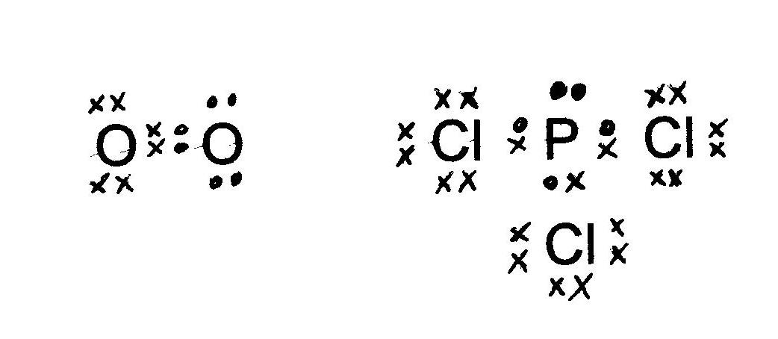
15
Oxygen gas Phosphorus trichloride 1 + 2 = (3)

16 The independent variable is the variable which is changed or manipulated.
The dependent variable is the variable which changes as a result of the
independent variable. (2)
Any appropriate example (2)

Section 3: (74 marks)

1 (a) The Limewater test – bubble the gas through limewater. If the solution turns
milky white, then the gas is carbon dioxide. (2)
(b) 2H⁺(aq) + CaCO₃(s) → Ca²⁺(aq) + H₂O(l) + CO₂(g) (2)
(c) (i) mass of calcium carbonate reduces
(ii) concentration of Ca²⁺ increases. (2)
(d)
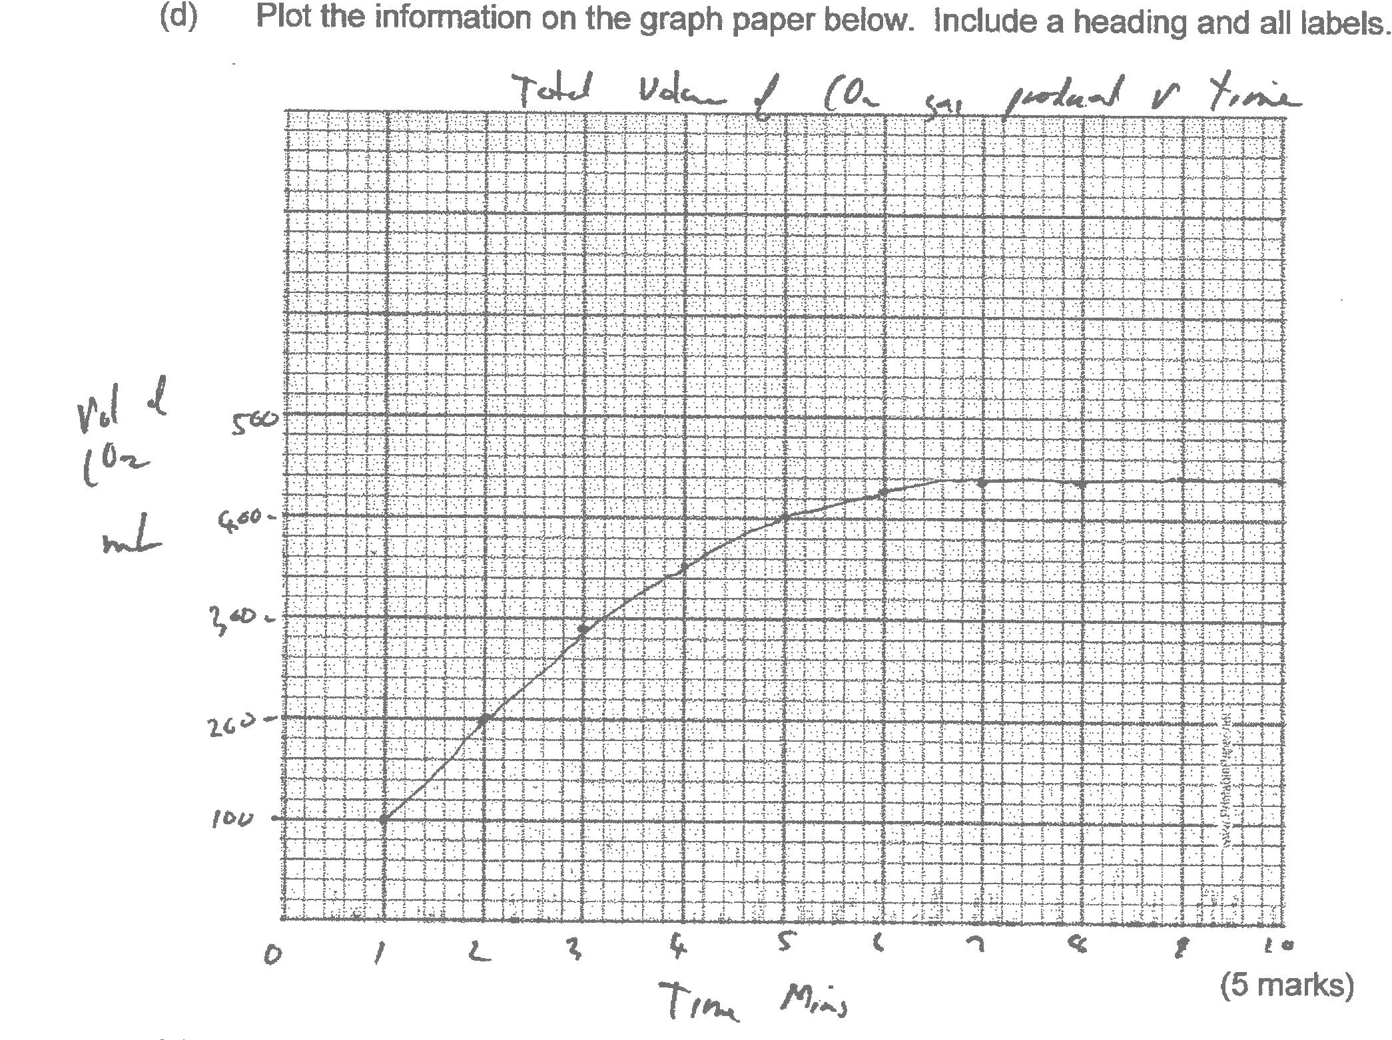

Total volume of CO₂ (g) in mL vs time in minutes

Vol
of
CO₂
(mL)
Time (min.)
(5)

(e) (i) The reaction rate decreases with time. (1)
(ii) The rate of reaction = ΔV / Δt = Δy / ΔX = slope of the graph (2)
(iii) The concentration of HCl decreased with time or the calcium
carbonate was used up. (1)
(f) The volume of gas after 12 minutes is 440 mL. (1)
(g) (i) Increase the rate of reaction (1)
(ii) Increased temperature increases the kinetic energy of the H⁺ ions.
This increases the proportion of ions with energies greater than E_{a},
causing an increase in the reaction rate. Also, more collisions
per second increases the reaction rate. (3)

2 (a) n(NH₃) = m / M = (750000) / (17.034) = 4.40 x 10⁴ mol. (1)
n(N₂) = ½ n(NH₃) = 2.20 x 10⁴ mol. (1)
n(H₂) = 3/2 n(NH₃) = 6.60 x 10⁴ mol. (1)

(b) n(NH₃) recoverable = 80% of 44030 = 35223.7 mol (1)
n(HNO₃) = c.V = 12 x 5000 = 60000 mol. (1)
SR NH₃ / HNO₃ = 1 AR NH₃ / HNO₃ = 35223 / 60000 = 0.59
Clearly, NH₃ is the limiting reagent. (1)

(c) n(NH₄NO₃) = n(NH₃) = 35223 mol. (1)
m(NH₄NO₃) = n.M = (35223 mol.)(80.052 g mol⁻¹) = 2.82 x 10⁶ g. (1)
_
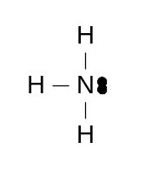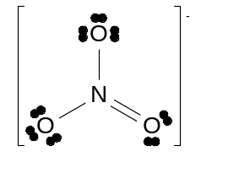
+
(d)
- H
H

-

2 + 2 = (4)
(e) Ammonium nitrate is used as a fertiliser – a source of soluble nitrogen.
It is also an explosive – acting as an oxidising agent
(It is also used in “cold packs” – the dissolving process is endothermic) (2)

(f) Litmus test: acid will turn litmus red. Ammonia solution turns litmus blue.
or: add a carbonate: bubbles of colourless gas will evolve with acid. (3)

3 (a) HClO ↔ H⁺(aq) + ClO⁻(aq)
Substance is acidic as H⁺(aq) is produced (2)
(b) HPO₄²⁻ + H₂O ↔ H₃O⁺(aq) + PO₄³⁻(aq)
HPO₄²⁻ + H₂O ↔ H₂PO₄⁻(aq) + OH⁻(aq) (2)

(c) NaOH(s) → Na⁺(aq) + OH⁻(aq)
NaOH is a strong base – it dissociates to produce OH⁻ in solution.
CO₃²⁻(aq) + H₂O(l) ↔ HCO₃⁻(aq) + OH⁻(aq)
CO₃²⁻(aq) is a weak base – hydrolysis occurs to a limited extent to produce
a low concentration of OH⁻(aq) (4)

(d) CH₃COOH(aq) + CH₃NH₂(aq) ↔ CH₃COO⁻(aq) + CH₃NH₃⁺(aq)
acid base conjugate base conjugate acid
In the reverse reaction, the conjugate base accepts a proton to become
the acid. The conjugate acid donates a proton to become the base. (4)

(e) H⁺(aq), HSO₄⁻(aq), SO₄²⁻(aq), OH⁻(aq) (2)

4 (a) (i) CH₃CH₃ + Br₂ → CH₃CH₂Br + HBr (2)
(ii) H₂C=CH₂ + Br₂ → CH₂BrCH₂Br (2)

(b) (i) Addition reactions occur with alkenes.
Substitution reactions occur with alkanes. (2)
(ii) In addition, the double bond is broken and the halogen is
added on both sides of the double bond
In substitution, H is replaced with halogen atom and
hydrogen halide is produced. (2)
(iii) Addition: Only one product (unless a geometric isomer)
Substitution: two products: haloalkane and hydrogen halide (2)

(iv) Addition reactions are more rapid than substitution reactions
under the same conditions. (1)

5 (a) (i) n(CO₂) = m / M = 2.91 / 44.01 = 6.61 x 10⁻² mol (1)
(ii) n(C) = n(CO₂) = 6.61 x 10⁻² mol (1)
(iii) m(C) = n.M = (6.61 x 10⁻²)(12.01) = 7.94 x 10⁻¹ g. (1)

(b) (i) H⁺(aq) + OH⁻(aq) → H₂O(l) (1)
(ii) n(NaOH) = c.V = 2.03 x 0.0657 = 1.33 x 10⁻¹ mol. (1)
(iii) n(Cl) = n(NaOH) = 1.33 x 10⁻¹ mol. (1)
(iv) % (Cl) = m(Cl) / (total mass) = (4.728 g) / (6.60 g) = 71.6% Cl (2)

(c) m(O) = total mass – [m(C) + m(Cl)] = 6.60 g – [5.522 g] = 1.08 g O (2)

END of SOLUTIONS

